

6CS005 High Performance Computing
Portfolio Part 2

Student Name: Pratik Dhimal
University ID: 2407779
Group: L6CG1
Tutor: Yamu Poudel
Submission Date: 11th January, 2026

Table of Contents
1. Task3: Password Cracking 1
1.1. Generate encrypted password in the CPU 1
1.2. Hash the encrypted password using SHA512 Algorithm 1
1.3. Hash all the possible password into SHA512. 2
1.4. Crack the password and store to file 2
1.5. Memory deallocation – freeing memory appropriately 3
2. Task 4: Sobel Edege Detection 4
2.1. Read image into CPU memory and store appropriately 4
2.2. Allocate GPU memory according to image size and transfer data to GPU 5
2.2.1. Allocating GPU Memory 5
2.2.2. Data Transfer to GPU 6
2.3. Edges detected correctly via the CUDA kernel function 7
2.3.1. RBGA to GrayScale Kernel 7
2.3.2. Edege Detection Kernel 7
2.3.3. Detected edeges to final RGBA kernel 7
2.4. Transfer Edege detected value safely to the CPU 8
2.5. Making final image and memory deallocation 8
3. Appendix 9

Task3: Password Cracking

This task is based on the implementation of the password cracking application built on the GPU platfor. Its implementation is done according to the particular conditions of memory management and kernel running, as well as data transfer. The overall flow of the programm is as follows.

Generate encrypted password in the CPU

In this process the PasswordGenerator.c file generates password in format aa11 where first two character is always lower cased alphabet and last 2 is always numeric valus. Then the 4 letter password is encrypted to a 10 letter password with simple asci conversion techniques. This password is than stored in a textfile as shown in Figure 1.

Hash the encrypted password using SHA512 Algorithm

As showin in Figure 2 , In this process the build in function from crypt() is used to hash the password which wash encrypted in above step. This function comes from crypt.h header file. What happens here is the program goes through each line of the initially encrypted password and than hashes it and store to a output text file as specified in the comman line.

Hash all the possible password into SHA512.

As shown in Figure 3, for the first time we utilized the power GPU to calcualte all the possible combination of our passwords and than encrypt it usign the same way like we did in the first step. So now we’ll have all the possible combination of encrypted but not hashed passwords which is 67600 in our case. Than as shown in Figure 2, the same CPU function is used to hash the 67600 passwords. Thus finally we’ll have 67600 properly hashed passwords usign the same algorithm as the target file.

Crack the password and store to file

As shown in Figure 4, brute-force search is initially performed on the GPU with all possible passwords generated correspondingly to the passwords by all possible password combinations and the encrypted/ hash values are stored in a large look-up table of 67,600 encrypted hash values. All the items in the table are distinct passwords based on a predetermined pattern and encrypted password. During the cracking, the CUDA kernel is executed to ensure that each thread in the GPUs has a single target hash. The thread then performs a comparison of its target hash against all the precalculated hashes in the table in sequence, the brute-force step of comparison. In case of a match, the matching table index is transformed back to the original plaintext password and the result is stored in the output; when no match is found after searching the entire table, a dummy(XXX) is stored instead. This scheme decouples the generation step of brute-force with the comparison step, thus enabling the costly password space to be calculable only once and then reused successfully to crack numerous target hashes at once.

Memory deallocation – freeing memory appropriately

Lastly as shown in Figure 5 , all the GPU and CPU memory is freed to make sure memory leak doesn’t happen.

Task 4: Sobel Edege Detection

Read image into CPU memory and store appropriately

In this step I have read the image file into CPU memory using then lodepng_decode32_file() function. This function decodes the image to its raw pixels form (RGBA for each pixels) and also gives the width and heigth in pixels. Later in the process, we’ll need to convert back the pixels value to image so we’ve created a memory space named h_out_rgba using the maclloc() function which will be used later. All of this process is given in Figure 6

Allocate GPU memory according to image size and transfer data to GPU

Allocating GPU Memory

Here cudMalloc() is used to allocate memory in the GPU, we have allocated memory for input rbga, gray converted, edeges detected, and output rgba for loding raw decoded rgba, storing converted gray values (one per pixel), detected edeges (one per pixel), output rgba to store the final manipulated rgba value respectively as shown in Figure 7 In my case the hck.png image is of 464 x 108 pixels and as a singel unsigned character holds 1 byte of memory so the memory allocation looks soething like this as showin in table below:

Input RGBA | 200448 bytes
GrayScale | 50112 bytes
Edeges | 50112 bytes
OutPut RGBA2 | 200448 bytes

Data Transfer to GPU

Now we have allocated sufficient memory in the GPU, we need to transfer data to it. We just transfer the raw decoded pixel value to the GPU as all other memory address will be filled by GPU itself by performing pixel manupulation. As shown in Figure 9, cudeMemcpy() function is used to transfer the data to the GPU we need to keep in mind the last argument is the direaction and it must be cudaMemcpyHostToDevice as we are copying from host(CPU) to device (GPU). How we have the required data in the device.

Edges detected correctly via the CUDA kernel function

RBGA to GrayScale Kernel

In this kernel we pass all the raw rgba value and it converts to grayscale intensity value using the human eye adaptive formula for grayscale based on luminiosity weights rather than a normal average method we used to use in the past as showin in Figure 8.

Edege Detection Kernel

As showin in Figure 10 ,this kernel performs the main logic of edege detection. Here we have two gradient Gx and Gy which is used to mease the rate of change of intensities in horizontal and vertical direction respectively.I t wokrs by multipling each value of the gradient kernel with its corrosponding grayscale value, and this step is repeated for each and every value of the grayscale intensity. So now we have both the gradiet in horizontal and vertical direction, then, the formula $\sqrt{{Gx}^{2}+{Gy}^{2}}$ is used for the effective magnitude of intensity change. Lastly, the edeges values are populated to the d_edges variable.

Detected edeges to final RGBA kernel

We had one value per pexel in the gray scale intensity value now this kernel populates the value to all the RGB to make a perfect set of RGBA value as shown in Figure 8 ,the A (transparency) is set to 255 for a perfectly opaque imag. This makes sure we can later use the perfect set of RGBA to generatre output edege detected image.

Transfer Edege detected value safely to the CPU

As shwon in Figure 11 ,the cudeMemcpy() function is used with direction argument cudaMemcpyDeviceToHost to copy the final manipulated edege detected pixel value to the h_out_rgba. Now our Host(CPU) has the final sets of pixel value which could be easily encoded to a png image using the lodepng.

Making final image and memory deallocation

Finally the lodepng_encode32_file() function is used to encode the pixel back to png image. This gives us a final png image named sobel-final-image.png as shown in Figure 14 .Lastly, we free all the memory used by the GPU as well as CPU to prevent memory leaking.

Appendix

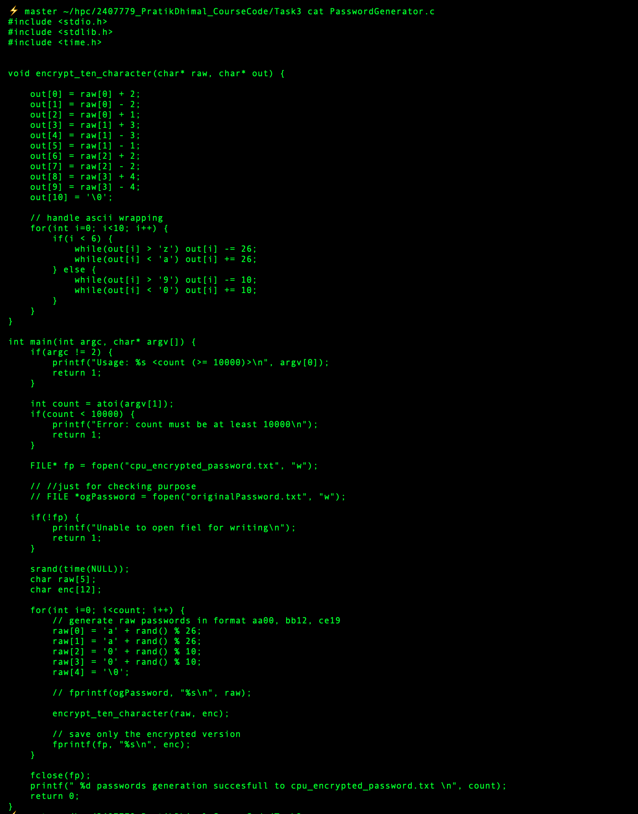
Figure 1 PasswordGenerator.c

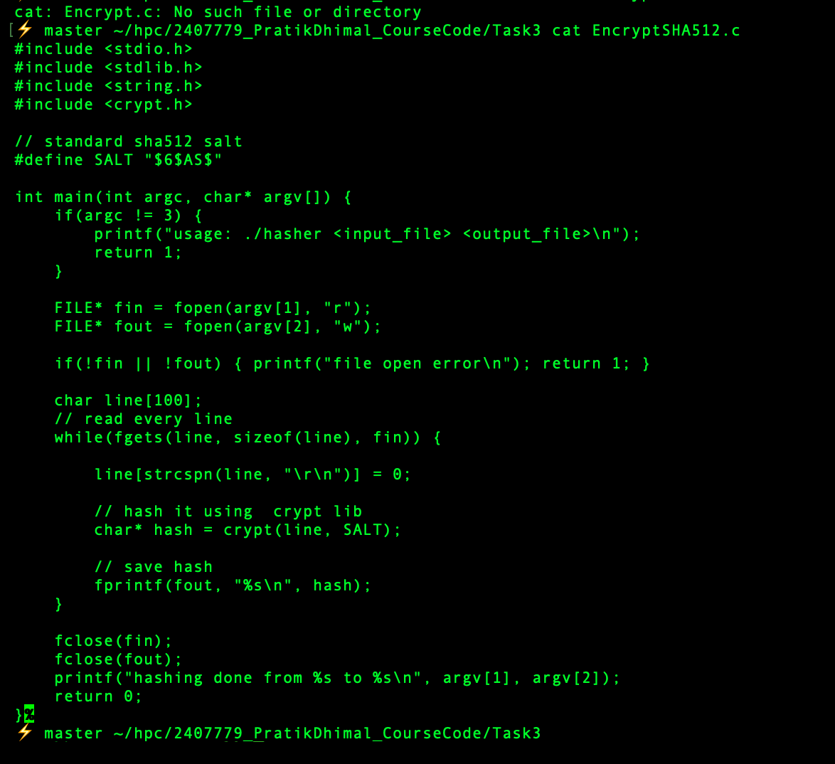
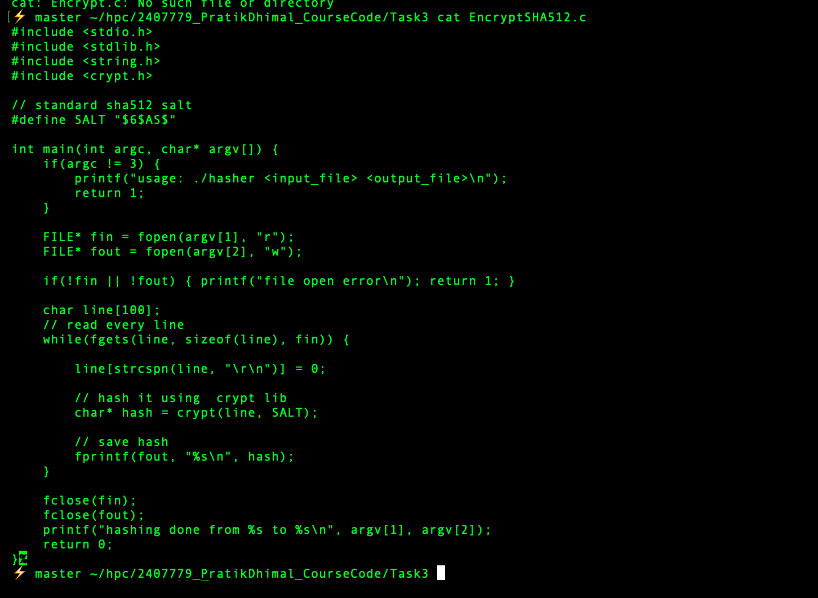
Figure 2 EncryptSHA512.c

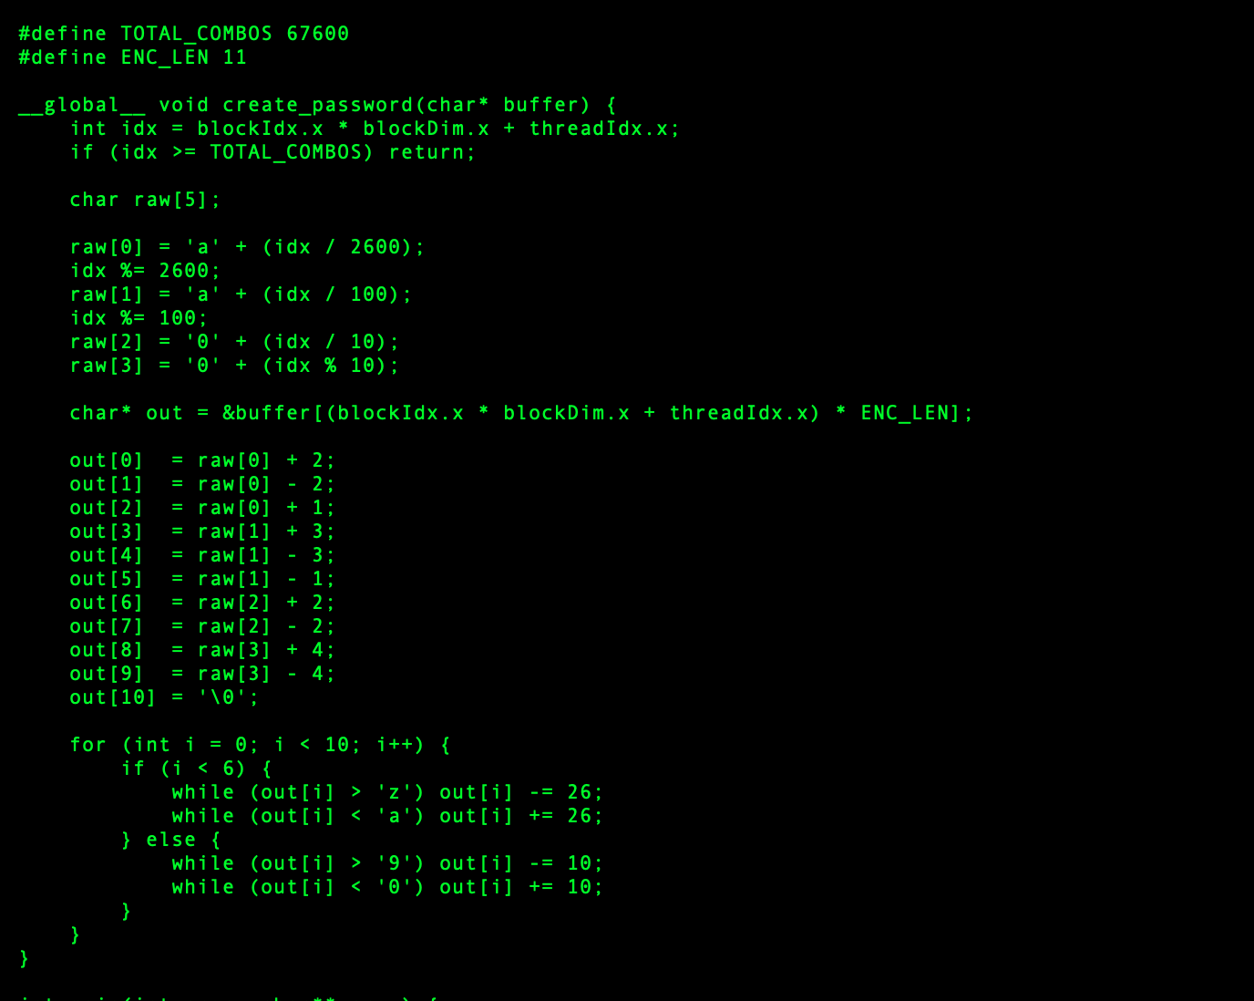
Figure 3 Password Generation Kernel
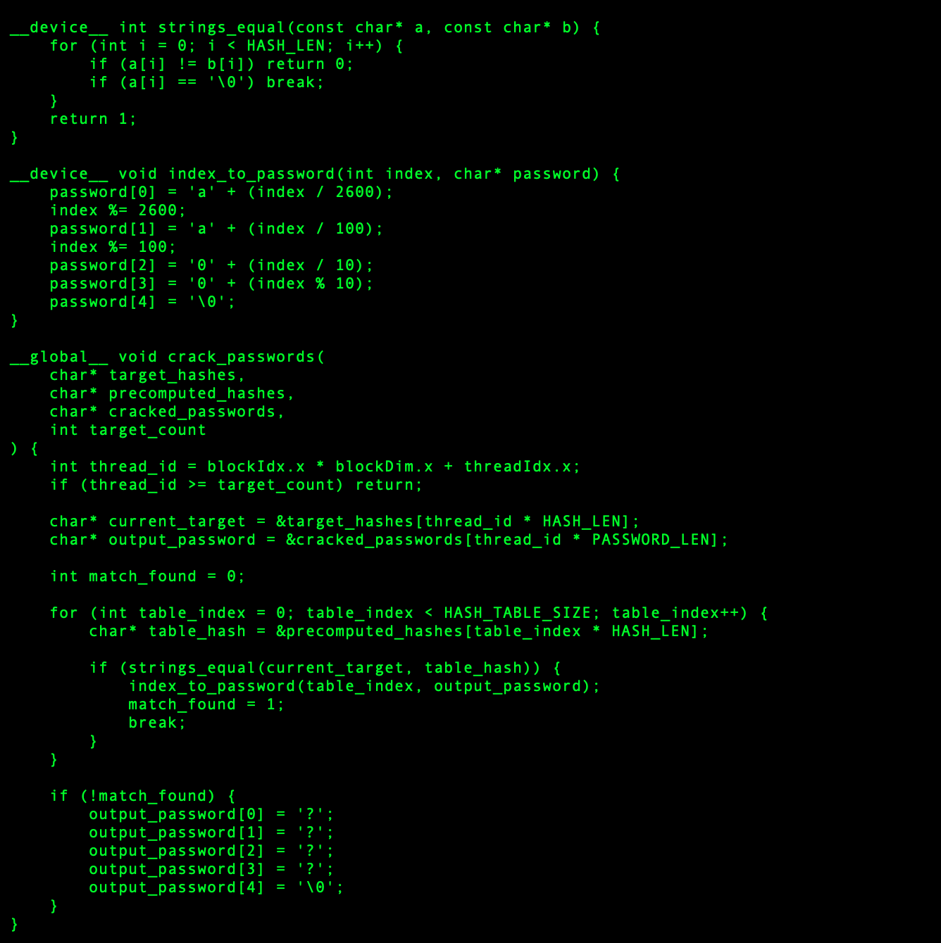
Figure 4 Crack Password kernels

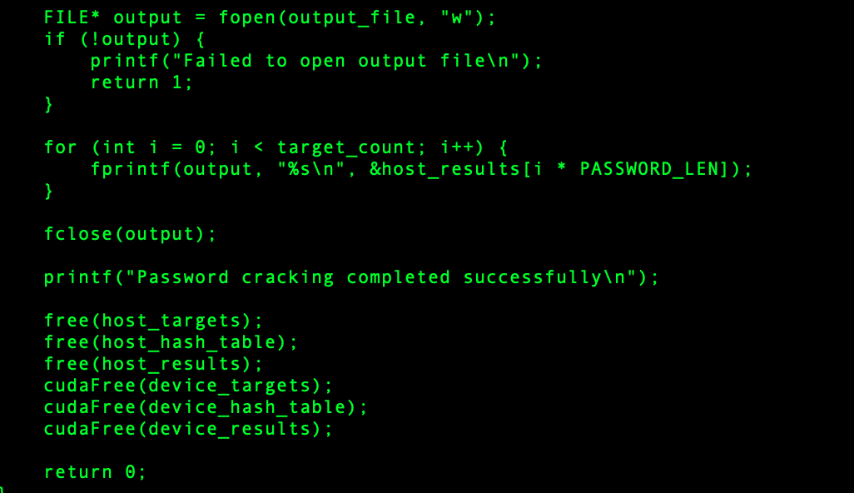
Figure 5 Memory Deallocation

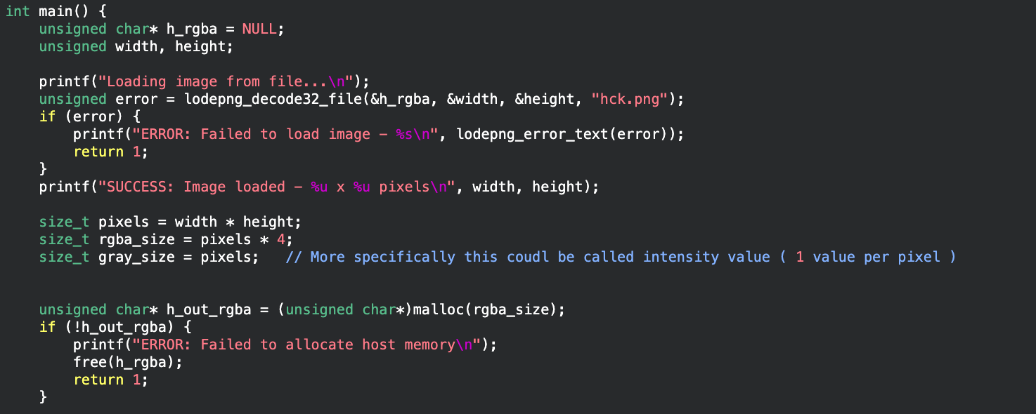
Figure 6 loadign image to cpu memory

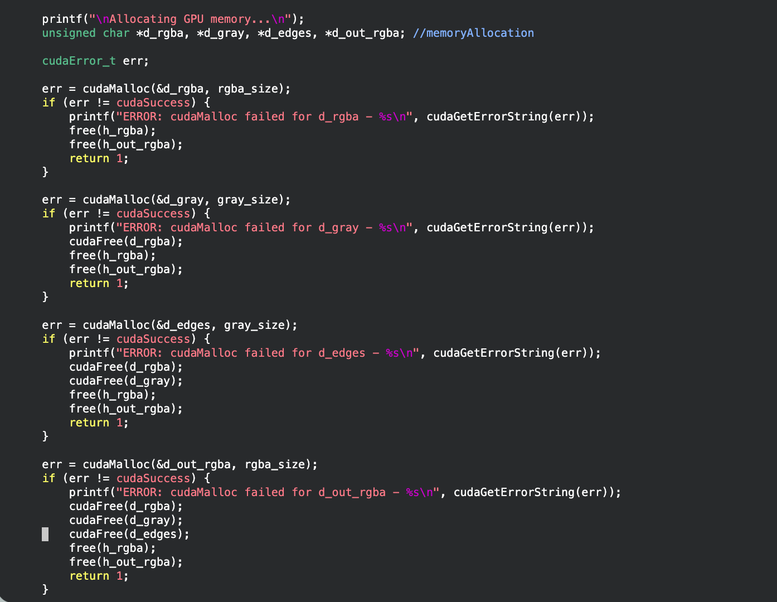
Figure 7 Memory Allocation to GPU

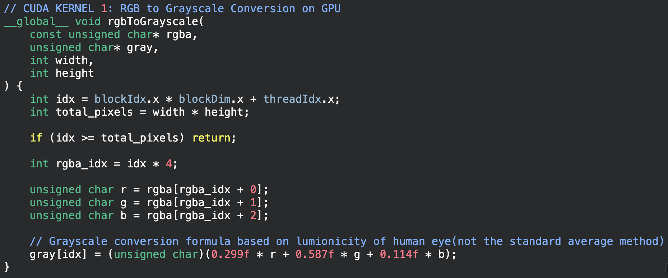
Figure 8 rgb to grayscale kernel

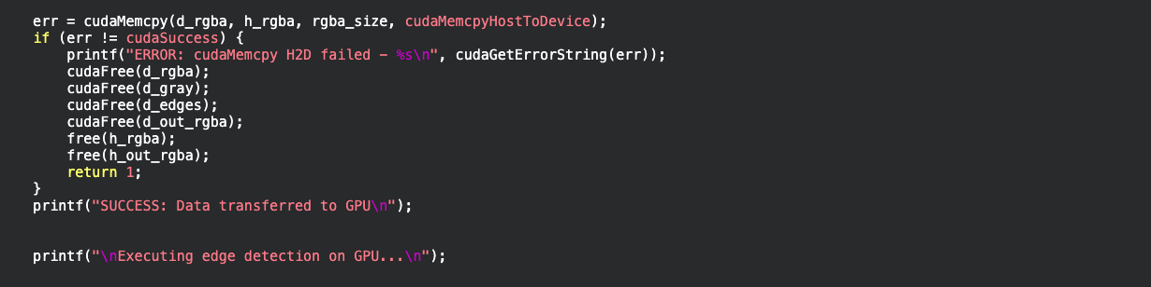
Figure 9 copying data to GPU for pexel manipulation

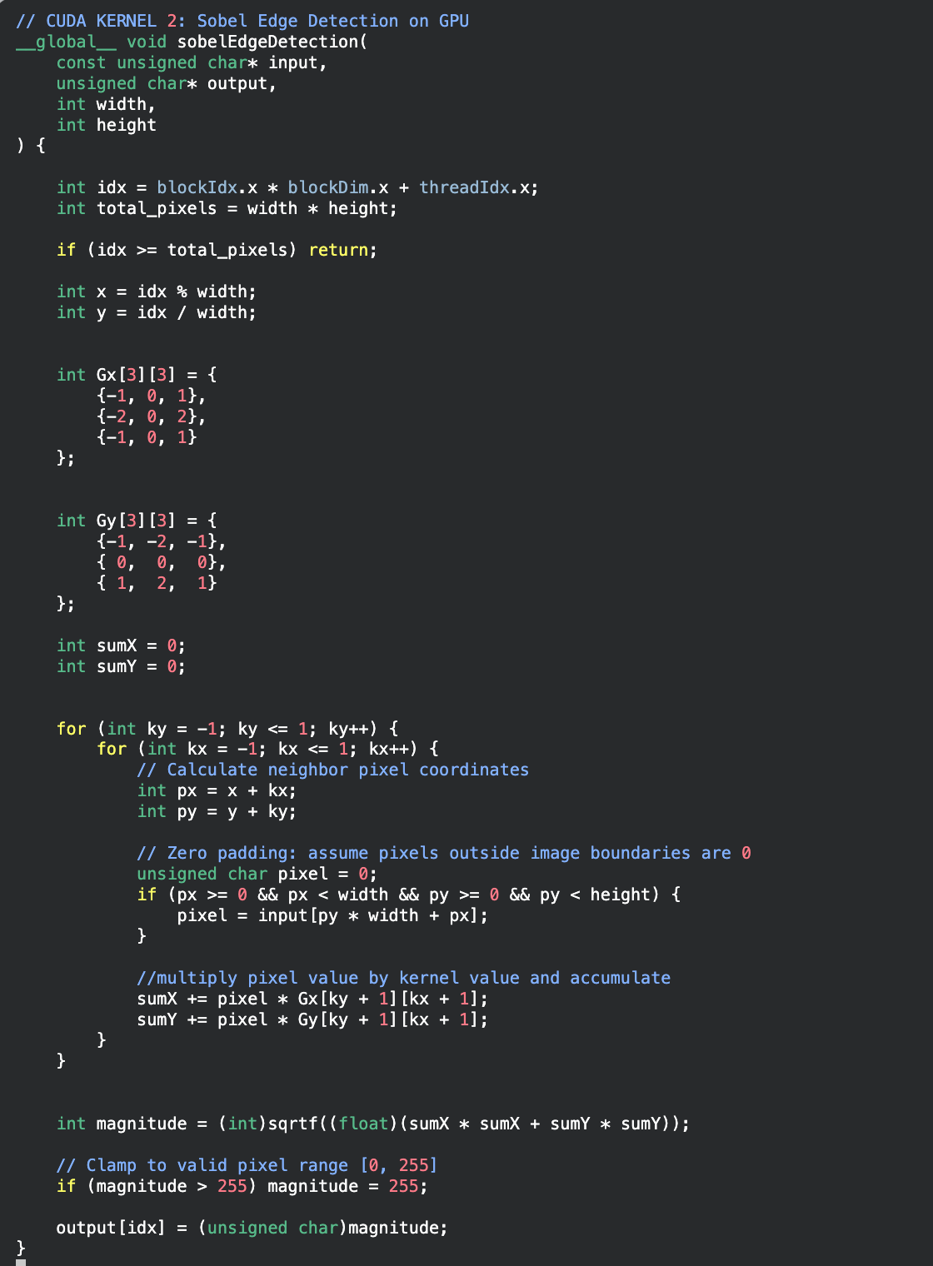
Figure 10 sobel edege detection kernel

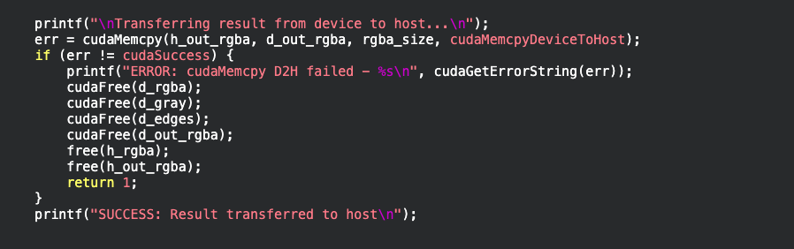
Figure 11Final rgba value copy to host

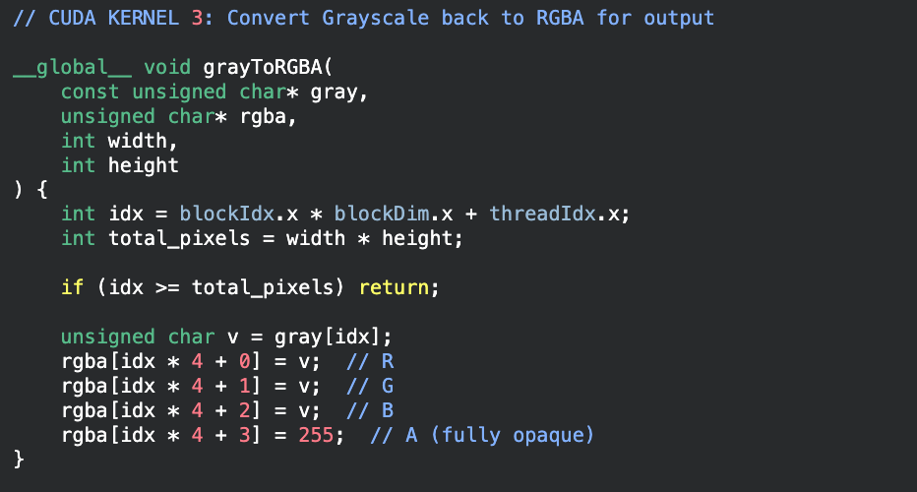
Figure 12 graysacel to rgba kernel
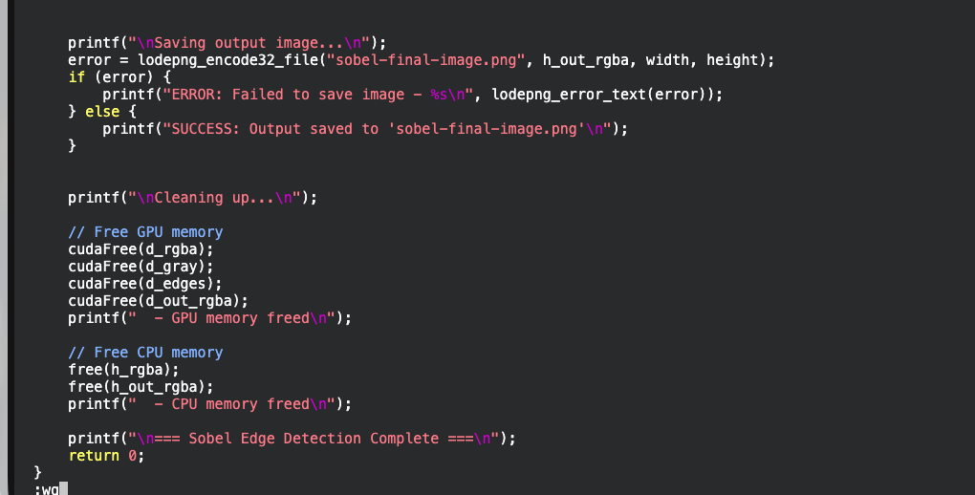
Figure 13 memory deallocation


Figure 14 output image

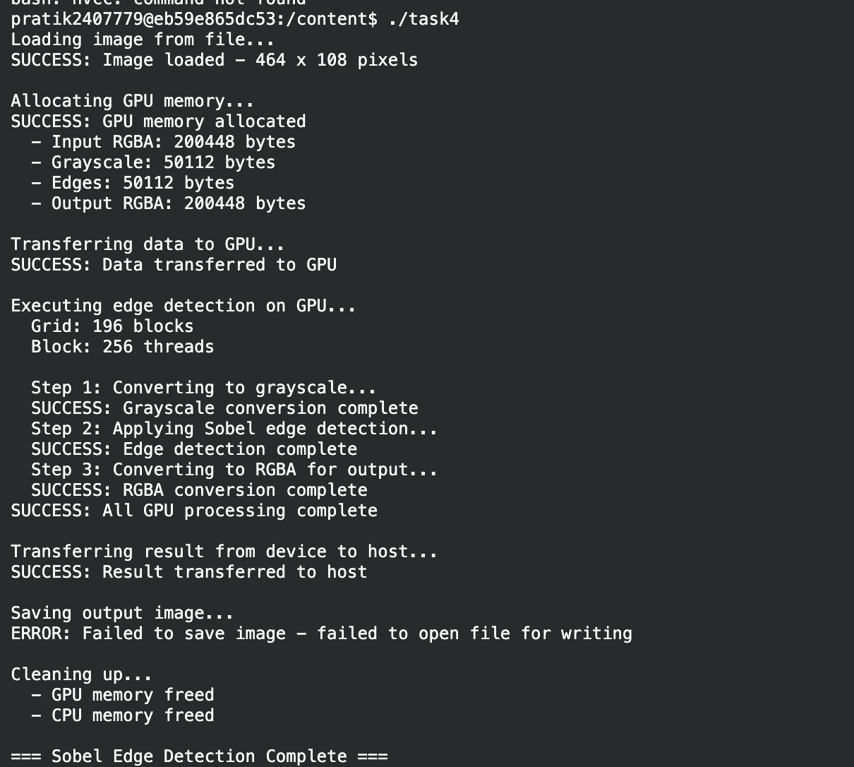
Figure 15 output commandline

